***Graphing for Change***

***Software Users Manual***

UBC Okanagan

Graphing For Change

Reece Walsh

Mar 21 2018

Version 3

______________________________

[Project Lead Signature Block]

______________________________

[Project Manager Signature Block]

**Revision Sheet**

|  |  |  |
| --- | --- | --- |
| Revision | Date | Brief Summary of Changes |
| Version 1.0(draft) | Feb 21 2018 | Baseline document draft |
| Version 2.0(draft) | Mar 9 2018 | New information relevant to functions added |
| Version 3.0 | Mar 23 2018 | Revised information regarding export functionality. Added new tutorials and explanations regarding functionality. |

**INTRODUCTION** **4**

Document Use 4

Definitions and Acronyms 4

Key Acronyms 4

Key Definitions 4

References 4

**Concept of Operations** **4**

**General Use** **5**

Page Navigation 5

Google Maps 5

**Procedures and Tutorials** **5**

**Navigational Features** **7**

**Error Messages and Problem Resolution** **7**

# **INTRODUCTION**

This manual is a comprehensive guide for users of the graph generation tool of Mapping for Change. The contents within give a detailed explanation of the graphs and reports contained within the tool, and the information required for analysis and generation of these components. This document supports all types of users, ranging from those visiting the graph generator for simple viewing purposes, to those using it as a tool for in-depth analysis and fully customized reports.

## **Document Use**

This document serves as a guide for those using the functions of the Graphing For Change tool. The document is divided into directional portions (section 4) and troubleshooting or reference portions (section 5 or 7). Any guides/walkthroughs assume the user is running the Windows operating system so some commands or shortcuts may differ on other operating systems. This document supports users from all backgrounds whether it be social workers, data analysts, or government planners.

## **Definitions and Acronyms**

### **Key Acronyms**

API: Application programming interface

CDN: Content delivery network

CTRL: The Control key located on a keyboard

CMD: The Command key located on a Mac keyboard

### **Key Definitions**

## **References**

* [Google Charts Library](https://developers.google.com/chart/interactive/docs/)
  + Licensed under the [Apache 2.0 License](http://www.apache.org/licenses/LICENSE-2.0)
  + Used for rendering and displaying all charts on the website
* [Google Maps Javascript API](https://developers.google.com/maps/documentation/javascript/)
  + Licensed under the [Apache 2.0 License](http://www.apache.org/licenses/LICENSE-2.0)
  + Used for the rendering and display of all map diagrams

# **Concept of Operations**

Graphing For Change is designed to serve the user with graphs based on data from i-Search Kelowna (<https://isearchkelowna.ca/>). Graphs are generated with data from a relational database and may change over time as data is collected or manipulated. Graphs are generated in real time so any changes made to the backend database are reflected immediately on graphs upon a new page load. These graphs will help analysts and city planners decide how to best allocate any additional resources to support people in need.

# **General Use**

Graphing for Change is centrally hosted and web browser based and does not require installation of any additional plugins for use. Users should ensure JavaScript is enabled in their web browser. Users can zoom in for accessibility purposes with CTRL +. Should a page appear to load improperly, or the page seems out of date, refreshing the page (CTRL+R) will update its contents.

### Page Navigation

To move the page up and down do one of the following:

* Scroll your mouse wheel up or down
* Use the bar on the far right hand side by either dragging the central bar up and down, or clicking and holding the arrows down on the extremities.
* Click on one of the headings under Overview on the top left hand side of the page to instantly jump to that section of the website.
* If device supports touch functionality, swipe the screen with a finger.

### Google Maps

To interact with a Google Map, place your cursor over the map.

Once the cursor is inside the map area, the following can be done:

* Zoom in: Scroll Up, click ‘+’ symbol on bottom right
* Zoom-out: Scroll down, click ‘-’ symbol on the bottom right
* Change Portion Viewed: Drag with the mouse
* Change view: Map or Satellite maps: click top left buttons
* Toggle map labels: Hover over the map and satellite buttons on the top left. A menu will drop down with an item called labels. Click to toggle
* Expand to full screen: Top right button with a rectangle, click it
* Exit full screen: Top right button again, or press the escape key on your keyboard
* Enter Street View: Click and drag the man icon on the bottom left to a location on the map that you would like to view at street level.
* Exit Street View: Click the back arrow in the top left corner beside the location information.
* Navigate Street View: Click one of the white arrows to move in that direction, or double click in the direction you want to go. Click and drag to rotate view.

# **Procedures and Tutorials**

Graphing for Change has been designed to minimize complexity of the end-user interface, thus the process of viewing charts is relatively simple. Upon loading the main page in your web browser, charts are immediately available for viewing and particular charts can be selected with the sidebar on the left of the screen. Users can also scroll down the page to view the various charts.

Certain charts have interactive features where the user can hover the mouse to learn more about a particular data value. This helps to avoid confusion with regards to reading and understanding the data. Data shown in tabular form can be sorted on columns by clicking the header label. Clicking multiple times toggles between ascending and descending order.

Usage of a Google Maps chart is denoted as follows:

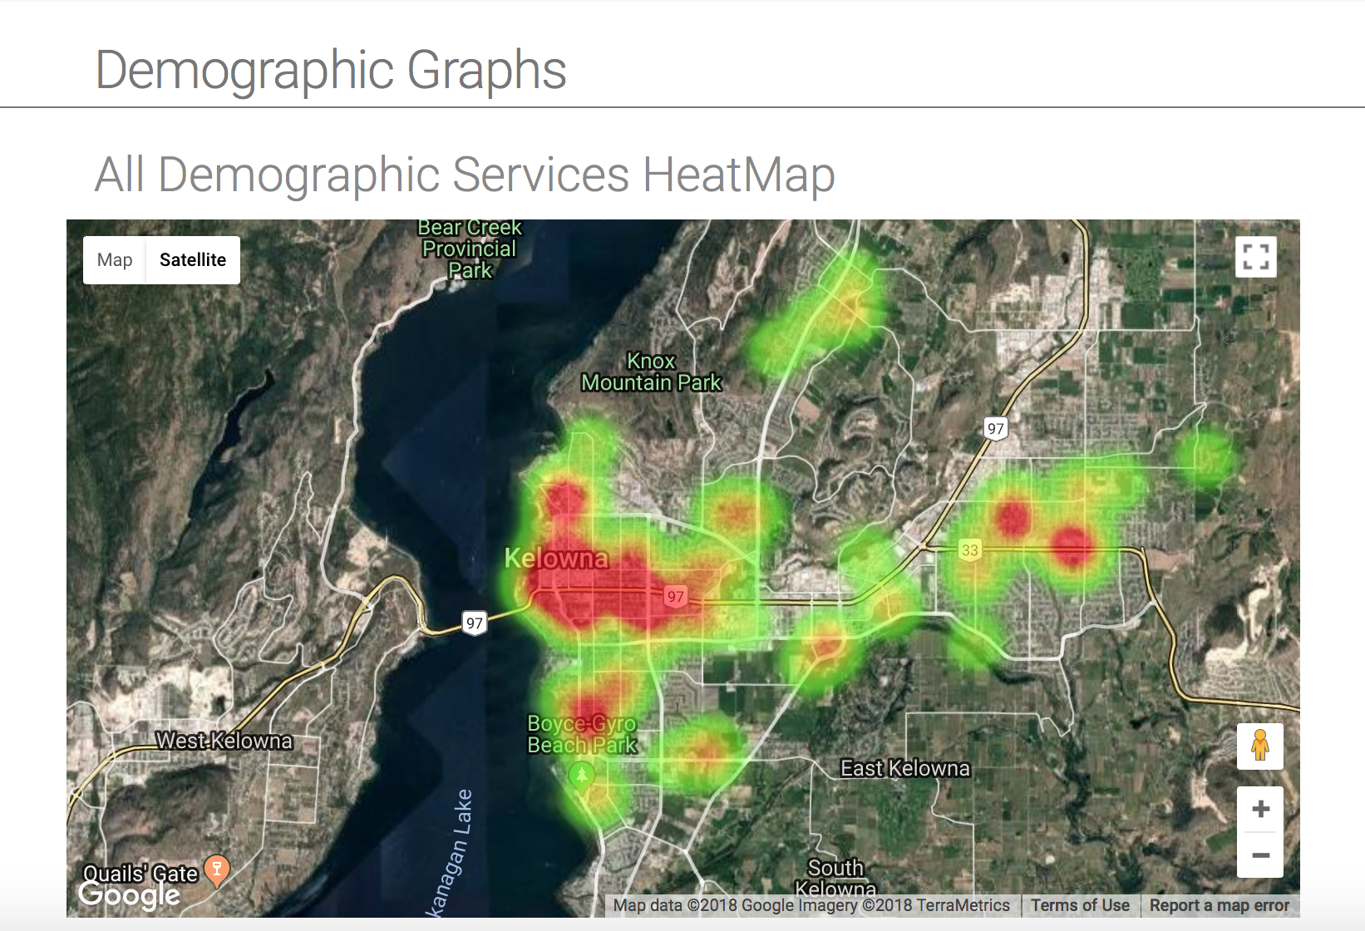

* 1) Graphs that plot on a map are pannable by clicking and dragging around the map. An example map is pictured above.
* 2) Clicking the square symbol in the top-right corner of a map chart will make that chart full-screen, making it easier for analysis. The escape (Esc) button will exit full screen mode.
* 3) The user may zoom in/out of the graph with the use of their scroll wheel while moused over the graph, actively scrolling, and holding either the CTRL (or CMD on Mac) key.
* 4) The user may also zoom into the graph with the use of the on-map button, located in the bottom-right corner on the screen. The + button will allow the user to zoom into the graph and the - button will allow zooming out.

# **Navigational Features**

The left sidebar allows switching the main view pane between graphs. Map charts can be panned with click + drag of the mouse. The top navigation bar changes the view from the home view, where graphs and charts are displayed to a view where reports can be generated. Users will most often be scrolling on the main view where charts are displayed or panning on a map.

# **Error Messages and Problem Resolution**

|  |  |
| --- | --- |
| **Problem** | **Fix** |
| Page loaded; no graphs loading | * Check internet connection * Check JavaScript is enabled in web browser * Google charts library server may be offline; wait for it to come back online |
| I think data is missing on a chart | * Perform a hard refresh of page * Clear browser cache |

**Index**

|  |  |
| --- | --- |
| Key Word | Sections |
| Error | 6 |
| Google Charts | 5 |
| Help | 3 |
| Usage of a website | 3, 4 |
| Google Maps | 3, 5 |